Russian Federation-UNDP Trust Fund for Development

Template of Project Annual Narrative and Financial Progress Report
(approved by the 6th meeting of the TFD Steering Committee)

30 January 2020

Russian Federation-UNDP Trust Fund for Development (TFD)

Project Annual Narrative and Financial Progress Report
Project title: | Digital skills and opportunities for youth employment towards digital economy in the Kyrgyz Republic
Project ID: | 00114503
Implementing partner: | Ministry of Education of the Kyrgyz Republic
Project budget: | Total: 1,000,000 USD  TFD: 1,000,000 USD
Project start and end date: | February 2019 – June 2021
Period covered in this report: | February-December 2019
Date of the last Project Board meeting: | February 2019
SDGs supported by the project: | Youth and 2030 Agenda: The importance of Youth is recognized in the 2030 Agenda for Sustainable Development and SDGs which set out to ‘substantially increase the number of youth and adults who have relevant skills, including technical and vocational skills, for employment, decent jobs and entrepreneurship’ by 2030 (target 4.4). Over a third of the global 169 SDG targets highlight the role of young people and the importance of their empowerment, participation, and well-being. 20 targets across six SDGs (2, 4, 5, 8, 10, 13, 17) are strongly focused on youth: Zero Hunger, Quality Education, Gender Equality, Decent Work and Economic Growth, Reduced Inequalities, and Climate Action.

1. EXECUTIVE SUMMARY
Kyrgyzstan has a rather young population (median age is 24 years, and people of working age constitute 60% of total population), so the demand for jobs in this age group is high. Women and young people have a higher chance of being unemployed than middle age men. 1/5th of young men, chose to seek job opportunities abroad. They mostly occupy relatively low paid work in services (retail, catering, cleaning, utilities etc.) and construction in Russia and other countries. Expert surveys show that the number of citizens of Kyrgyzstan working abroad is over 800,000 people (with 30 % of women migrants).

In 2017 the Government of Kyrgyzstan announced the launch of nation-wide program of digital transformation “Taza Koom” (Smart Nation) that aims to build an open and transparent state, aknowledge-based economy, raise living standards for Kyrgyz citizens, and improve the business environment. Taza Koom conception is a key component of the long-term 2040 National Sustainable Development Strategy which aims to enhance human capital and support innovations in harmony with the environment. The Projects Goal will be to help the Government of Kyrgyzstan to strengthen environment eco-systems protection capacity and advance opportunities for youth and especially young women in a digital economy, support their better integration into the global development community and create sustainable and worthy jobs. Coherent interventions suggested by the Project’s design will lay the groundworks for the following core objectives:

RESULTS:
Component 1: Improved digital skills development in the system of formal education
A technical assistance had been provided: a digital market research had been conducted, the education programmes, course curriculums, teaching standards and processes in the target technical universities were analyzed, main issues identified. The existing IT infrastructure in the two universities had been assessed.

Component 2: Established ITHubOsh in Osh City for young entrepreneurs and application of new learning models in non-formal educational settings
One hackathon and several training were conducted on following topics: 1) Project and product management; 2) Testing and quality assurance; 3) Front-End (Java Script); 4) Backend (Python); 5) development of simple business websites 6) robotics, etc. Over a hundred future Internet entrepreneurs learned business sales strategies on Amazon. UNDP partially supported the international conference on the topic of “Digital Transformation in Central Asia”.

Projects risks and lessons learnt are discussed. Plans are elaborated. Links related to the communication and visibility provided.

.

2. RESULTS
Component 1: Improved digital skills development in the system of formal education

Activity 1.1: Series of in-depth market studies and consultations with the private sector and experts knowledge on digital markets trends, digital jobs and recommendations on required set of skills that will contribute to country’s digital development, with additional focus placed on digital technologies and innovations in the priority sectors of economy;

Aziz Soltobaev, one of main co-authors of the Taza Koom National Digital Transformation Project was hired as a National Consultant to do the market research.

The purpose of this study was to provide an expert review of the level of digital skills and digital entrepreneurship in Kyrgyzstan. The product of this work is designed to help the Government of the Kyrgyz Republic, development partners and all stakeholders involved understand the role of innovation technology, the stages of access to digital technology, digital skills and develop the necessary initiatives and programs to achieve the target indicators within the framework of Sanarip Kyrgyzstan and the SDGs.

- Conducted series of in-depth market studies and consultations with the private sector and experts on the global and local digital markets trends, market demand for digital jobs and recommendations on required set of skills that will contribute to country’s digital development, with additional focus placed on digital technologies and innovations in all needed priority sectors on economy (agriculture, tourism, textile, e-commerce, apparel, information technologies etc..);
- Conducted in all regions including Bishkek deep field market research study of Kyrgyzstan’s innovation ecosystem and digital entrepreneurships to identify development opportunities;
- Conducted deep research on digital skills development, improvements, and recommend the best solutions;
- Conducted deep research of the level of market demand for digital skills and competencies of citizens and all civil services for G2C (Government to Citizens), G2B (Government to Business), G2I (Government to Investors);
- Prepared recommendations on how to develop digital entrepreneurship, startups, increasing demand for IT/ICT goods and services solutions, best lessons learned from developed countries;

Main topics are as follows:
- Digital Skills;
  - Digital literacy;
  - Competencies;
  - Skills;
  - Types of Digital Work and Employment;
- Stages of access to digital technology like logistical accessibility or security (Figure 1);

Figure 1. Stages of access to digital technology

- The population has access to smartphones, the Internet, but limited access to desktop devices;
- Citizens themselves learn basic digital skills, and advanced skills are available only in large cities;
- Internet users use their skills exclusively to use entertainment content;
- Digital State;
  - The state is actively implementing a digitalization strategy;
  - But not all online public services are gaining popularity among citizens;
- Digital economy;
  - Digital economy lags behind advanced;
  - Digital entrepreneurship is developing, but is limited by a number of factors;
  - Shortage of Supply for Advanced Digital Skills;
  - The government relies on digitalization of industries, but low cross-sectoral cooperation is observed in the economy;
- Digital Skills and Digital Entrepreneurship Development Program;
  - Necessary to boost overall digital literacy across in necessary to work in popular platforms;
  - Necessary to strengthen key digital competencies of civil servants;
  - Necessary to improve skills in providing public services for the population and business;
  - Developing intermediate specialized skills will strengthen the business position and potential of digital entrepreneurship;
  - Invest in Competencies for Advanced Digital Skills;
  - Promote digital professions for women;
- Expected Digital Results for Digital Skills Development
  - Develop a strategy to develop digital skills and competencies (Figure 2)

Figure 2. Adapted Pyramid of Digital Skills

Activity 1.3: Upgrading educational standards and curriculums for building fundamental and emerging digital skills to meet the growing demand of the digital economy, including digital inclusion standards for disabled and girls;

Activity 1.4: Introducing and piloting new educational standards and curriculums at the Kyrgyz State Technical University named after I. Razzakov (Bishkek) and Osh Technological University named after M.M Adyshev (Osh) and their subordinated vocational technical colleges and institutions;

Activity 1.6: Enhancing professional development of teachers through training and communities of practices to raise their awareness as well as the level of digital skills, help them understand the impact of digital technologies on their specific subject and encourage teachers to create digital content and pedagogic innovations.

With the national consultant team 1) Team Leader, consultant on Educational Standards, 2) IT based education consultant, 3) Legal consultant will conduct an assessment report of the current situation and needs for development of the technical specifications for modernization of the equipment, learning management systems and introduction of the new digitalized teaching standards in Kyrgyz State Technical University and Osh Technical University.
On November 21, 2019, the first stage of the process began, the experts Temir Kazybay, Zarlyk Jumabek uulu, and Almazbek Beishenaliev and UNDP representatives explained the current condition at the selected pilot educational institutions. The meeting with administrations of Kyrgyz State Technical University after I. Razzakov and Osh Technical University after M. Adyshev was organized, and education programs, course curriculums, training programs for academic staff, and technical base was discussed.
The education programs, course curriculums, teaching standards and processes were analyzed in detail by experts. Following analysis, it was exposed that there are huge gaps and shortcomings in this field of education. The implementation of the project and enhancement of technical infrastructure may lead to improvement in education process. However, a more conceptual approach is required to get a rational and purposeful outcome from the implementation of the project at these two leading technical universities, and the overall education system of the Kyrgyz Republic.
After several meetings with the Deputy Ministry of Education Nurlan Omurov (appointed in September 2019), he supported the implementation of a pilot projects for KSTU and OshTU and send an official order to universities (Attachment 1).

To achieve the results that are stated in Component 1 of the project, including preparation of National Digital Skills Development Strategy and Road Maps, modernization of education standards and education programs for the formation of fundamental and innovative digital skills, introducing and implementing on a pilot basis new educational standards and curricula in pilot educational institutions in Bishkek and Osh, strengthening the institutional potential at the selected pilot educational institutions in Bishkek and Osh, improving the professional quality of academic staff in the selected pilot universities in Bishkek and Osh, to implement the activities 1,3; 1,4; 1,5; 1,6, and for further progress of the project the following directions are recommended.

The proposed concept emphasizes the need for new educational standards for digital literacy, the training of which will be available to every citizen of Kyrgyzstan. In the framework of the Concept for the development of digital skills, the following priority areas are identified:
    - the introduction of digital education and the development of digital skills at all levels of the education system;
    - development of IT education, large-scale training of high-class IT specialists for the IT industry.
The most serious issue of the Higher Education Institutions
1) The mismatch between theory taught at education institutions and practice;
2) The professional quality and quantity of graduates do not meet the market demand;
3) Inadequacy of graduates’ practical knowledge;
4) Inefficiency of regulatory framework;
5) Simple and outdated IT infrastructure, which is in great need of modernization to improve the work of universities;

In order to solve the above stated issues and to improve the education system, it is needed to:
1) Re-define the function of universities;
2) To reform and optimize the higher education system in accordance with the market demand and future expected trends;
3) According to the above points 1 and 2, to prepare the teaching standards and education programs;
4) Introduce new regulations for the abovementioned standards.

To improve and implement the best solutions in educational standards was recommended to launch the 4th generation of education as a pilot project.

4th Generation University Model
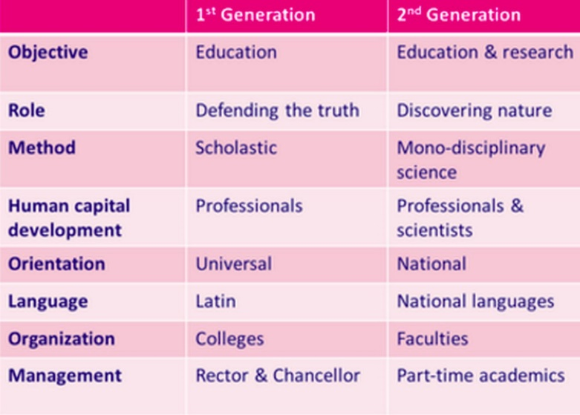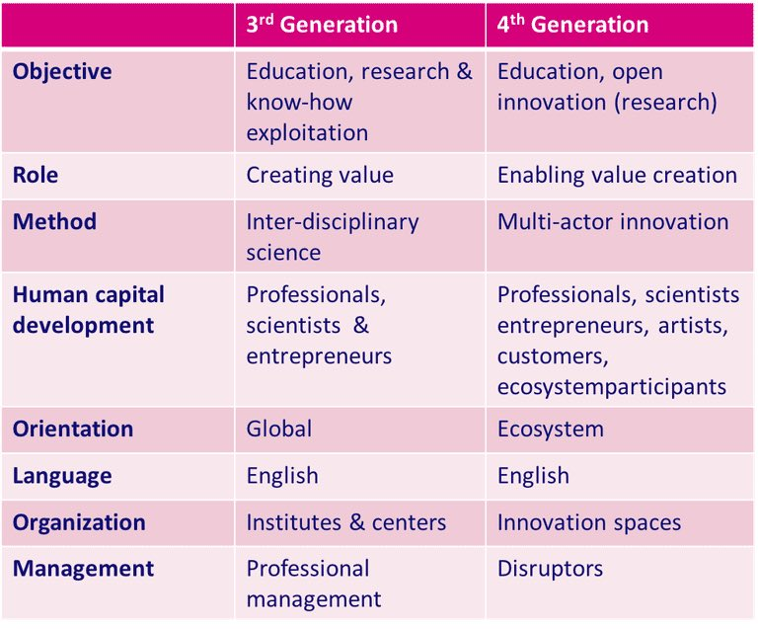
Together with our national consultants was developed draft of justification on realization of new educational programs (attachment 2) and sent back to the Ministry of Education.

Activity 1.5: Modernization of equipment and the introduction of new ‘digitalized’ teaching standards at the Kyrgyz State Technical University named after I. Razzakov (Bishkek) and Osh Technological University named after M.M Adyshev (Osh) and their subordinated technical colleges and institutions, including in apparel sector.
IT Infrastructure assessment results:
During assessment of the selected pilot educational institutions a number of shortcomings were identified in ICT infrastructure.
- Lack of computer lab equipment (currently very old computers are used)
- Poor network infrastructure (universities are not fully covered by LAN)
- Extremely poor Wi-Fi infrastructure (students are not able use Wi-Fi at all)
- Lack of servers and storages
- Lack of IT services for students
- Inexistence of IT incubators
To improve current situation, we recommend as first step, delivering two storage servers for each university which will help to host a number of ICT projects, applications and will help to the improve and support digitalization of the education process.
A tender was announced for totally four servers, and company selected, nowadays waiting for the contract signed.
Oracle Academy in Kyrgyzstan
Contacted with the Oracle Academy that they have professional platform and training contents. Oracle Academy offers an advanced computer science education system to disseminate knowledge and foster innovation, skills development and socio-cultural diversity in the IT industry worldwide. Oracle offers all trainings free of charge for Academic institutions and for our KSTU and OshTU pilot projects will be perfect solution.
Java courses and certificates:
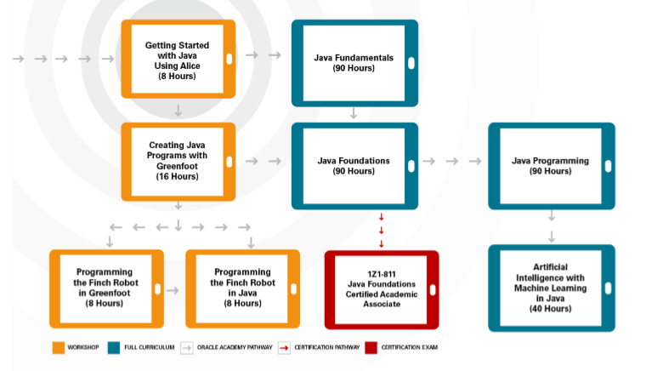
Database courses and certificates:
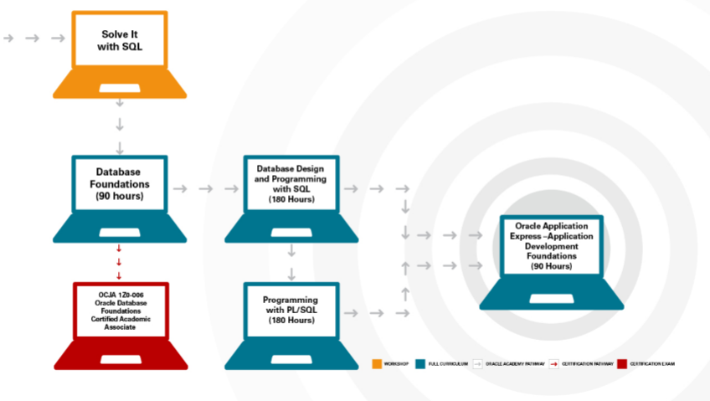
Oracle already sent the official partner agreement draft to the Ministry of Education (attachment 3).

UNDP supported Career and Practice Day at KSTU named after Razzakova
Over 800 people have learned more about digitalization and how to more effectively look for work and find exactly the industry in which work will bring not only profit, but also pleasure. On February 7, 2020, "Career and Practice Day" was held. This event is held in partnership with UNDP and there are more and more people who want to find a worthy use of their forces and knowledge. Among the participants were noted 150 graduate school students who are already planning their careers. In this they were helped by official representatives of almost 100 organizations and enterprises. Employers gave an extensive presentation of their institutions, conducted master classes on how to behave at interviews during dialogues of unemployed citizens with senior personnel departments. In addition, a presentation of the university was presented to schoolchildren, career guidance materials were distributed, and excursions were organized to the educational and laboratory centers of the university. In the framework of the problem of choosing a profession, a professional testing “Interest Navigator” was conducted for them. Much attention during the career fair was paid to the IT field. Participants were told about the relevance of the field of information technology. So Rehina learned a lot about programming. Now she intends to put more emphasis in improving her skills and radically change her life.
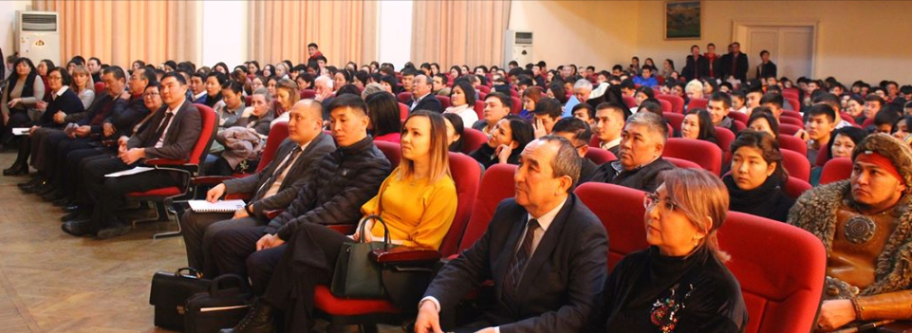
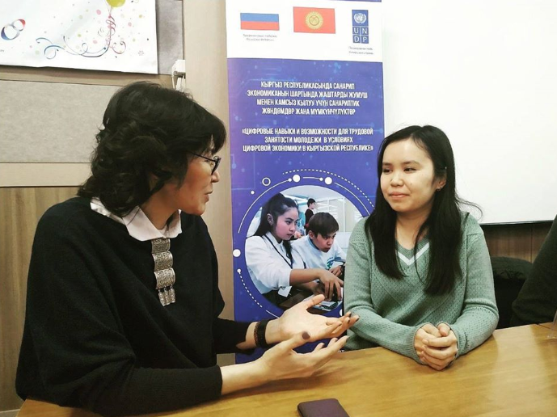

Component 2: Established ITHubOsh in Osh City for young entrepreneurs and application of new learning models in non-formal educational settings

Activity 2.1: Contributing to strengthening the infrastructure and institutional capacity of IThubOsh to serve creative space and new generation incubator to foster digital innovations, provide workspace, seed funding, access to new financing mechanisms, mentoring support and other support services.

An RFP tender has been announced and held, due to some legal clarifications on the quality of documents submitted by the finalist, the UNDP procurement department is awaiting clarification from headquarters.

Activity 2.2: Supporting a series of hackathon/hackfest events to engage young computer programmers, interface designers, private sector project managers and subject-matter experts to collaborate on the designing of new business scalable solutions and software products;

Hackathon: Conducted two days hackathon event in Osh for 72 participants. Selected groups developed and presented projects as:
- TMG - B2B - Service excluding sales agents;
- IT function - Flash delivery - Food and food delivery service;
- Disguise - Car wash - Car wash reservation system;
- Brain Soft - Express Banking - Application for banks with a bot;
- Ducks - Pony CRM - CRM for Small Business;
- Generation X - LMS for online learning with gamification;
- Front End Squad - Platform for cafes and restaurants;

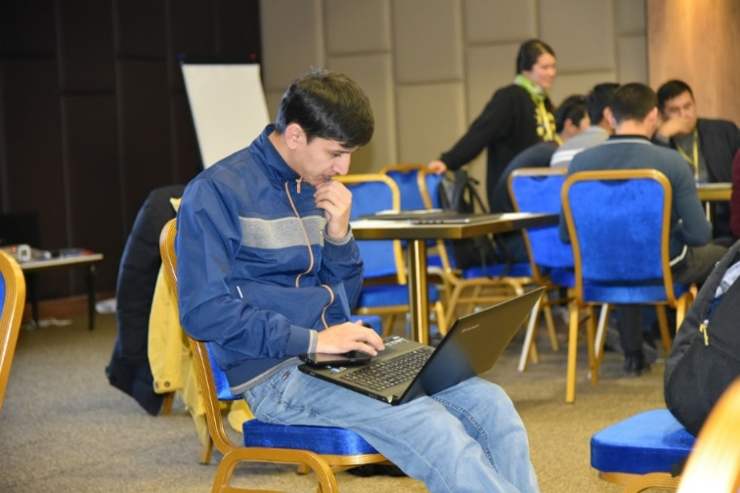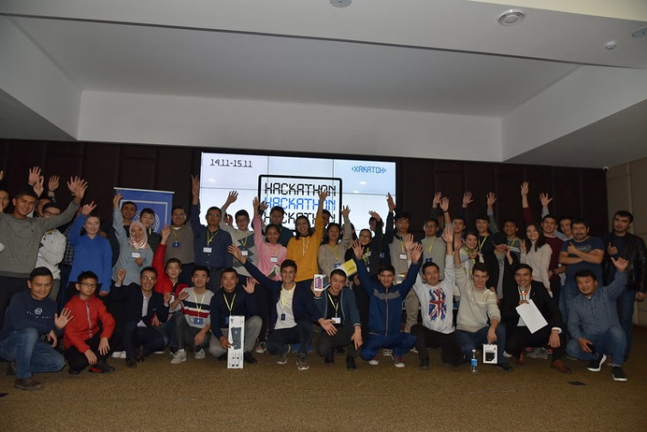

Master Class Trainings: Conducted master class trainings for 70 youth participants in Osh on November 15, 2019 on the following topics: 1) Project and product management; 2) Testing and quality assurance; 3) Front-End (Java Script); 4) Backend (Python)
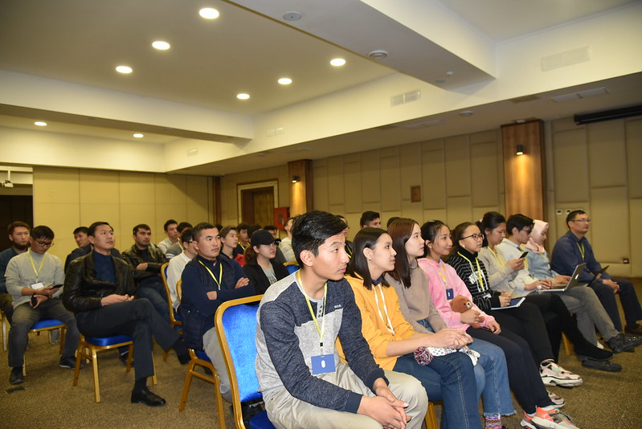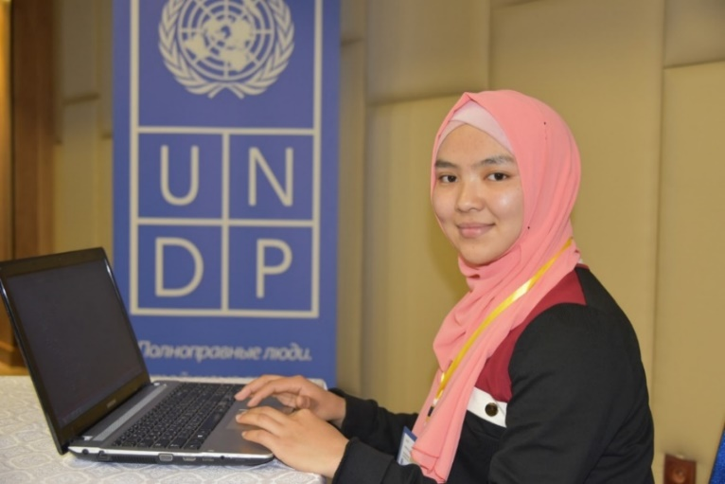
To participants, hackathons give the ability to work together in a team. They are immersed in an environment of people with common interests. Out of 9 teams, only four received prizes. The rest gained experience and new contacts. The guys had to not only create, but also present the game to the public and rivals. In a friendly atmosphere, the protection of the project carries only positive emotions, as it turns into an open discussion and exchange of ideas. In this case, even if your project is imperfect, the experience of a public demonstration will only help you strengthen your leadership skills.

Trainings for politicians and entrepreneurs:
On November 30, trainings were held in Bishkek to develop their own simple business websites and online sales, in which businessmen and popular Instagram stars / bloggers participated. The total number of people was 21 people.
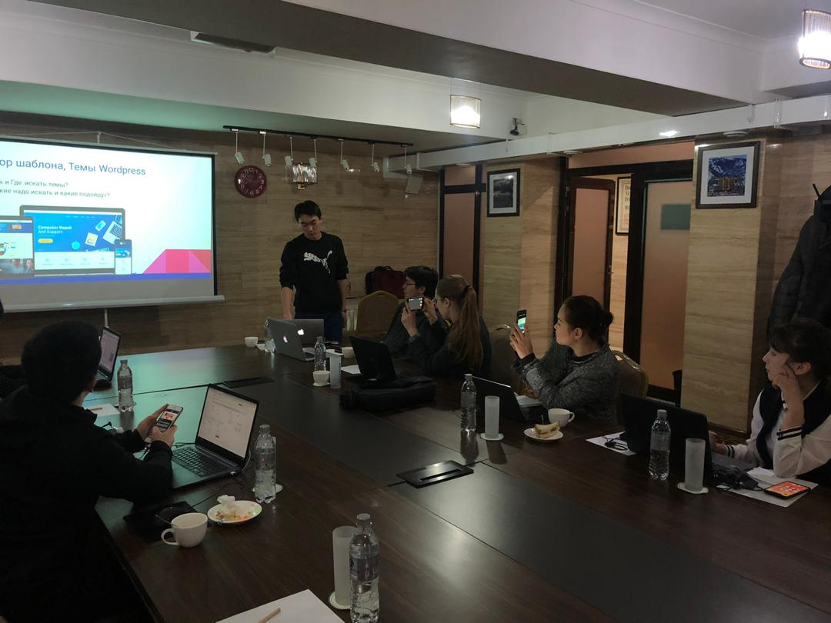
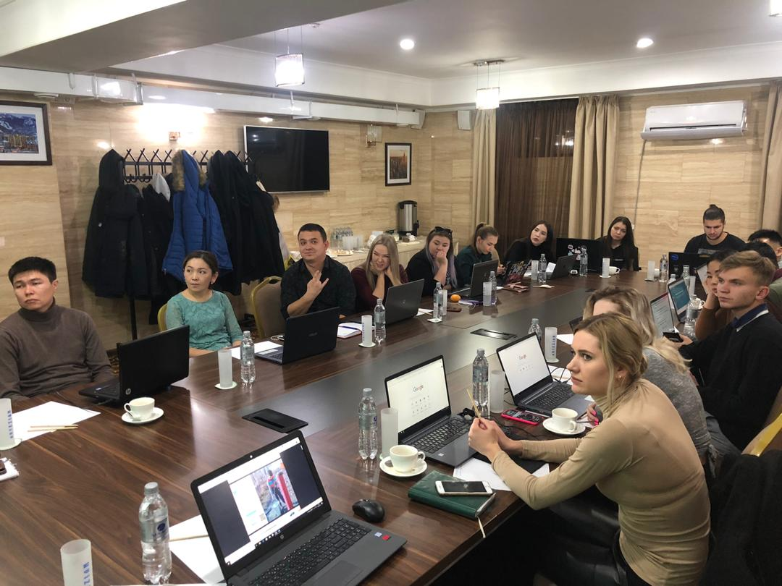

Robotics trainings:
The long-awaited robotics competitions among schoolchildren of the city “ROBOSKY TECH FEST - OSH” – 2019 8th of December were held in Osh. The project is timed to the Year of Regional Development and Digitalization of the country and was organized in order to develop schoolchildren’s interest in inventiveness and improve innovative thinking, as well as to improve their creative abilities.

For a month and a half, children from vulnerable families, together with children with a penchant for robotics, took courses specially organized for them. Children became familiar with the concepts of "Robot", "Robotics" and "Safety". The initiative was aimed at raising youth awareness of the possibilities of using robots in various fields of human life, to understand the importance of robotics, the history of technological development from mechanical devices to modern robots.

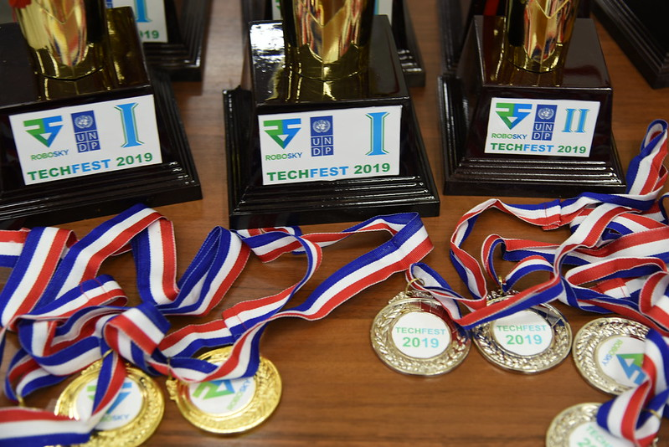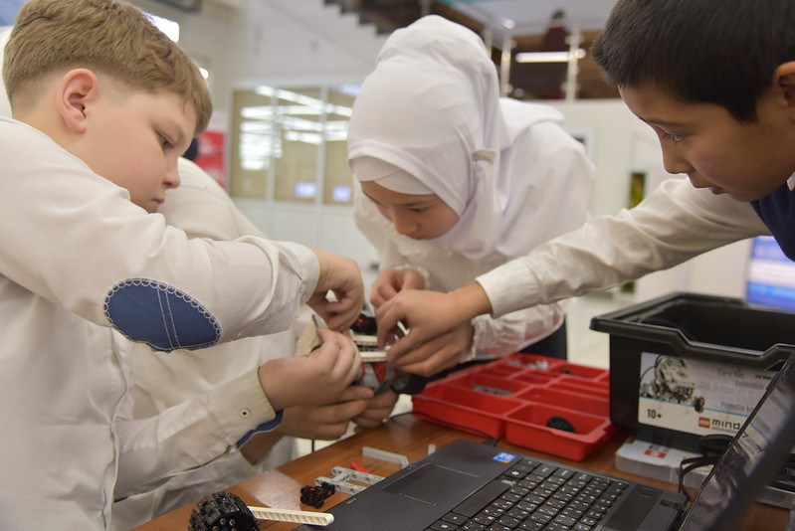

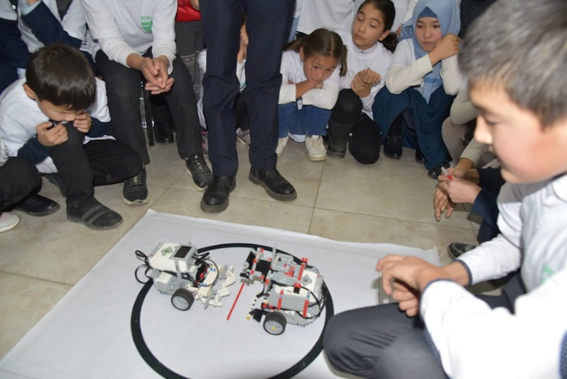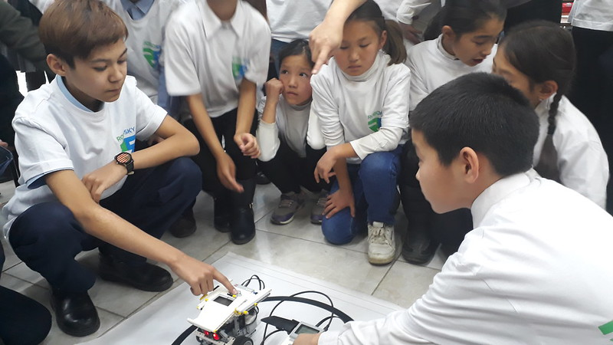
Amazon Meetups:
In the age of modern technology, the Internet space is becoming increasingly popular, becoming the necessary platform for everything. Despite the fact that the traditional market is not without demand, electronic commerce is gaining tremendous momentum. On December 8 and 12, in the cities of Bishkek and Osh, with the support of UNDP, over a hundred future Internet entrepreneurs learned business sales strategies on Amazon.
The speakers told the participants how to trade on Amazon, the world-famous venue. Some of them have already begun to create their online business plan. For example, Saikal Orozova intends to supply women’s handbags from China, and sell them on Amazon. After all, now she knows all the intricacies of electronic commerce, and this training gave her an impetus to start her online business.
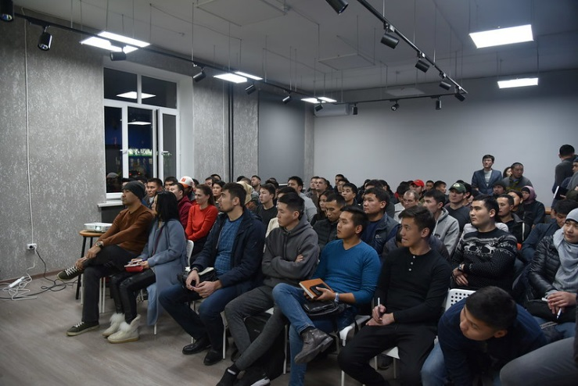
Digital and cyber security event in High Technology Park
UNDP supported the digital and cyber security event in Bishkek together with High Technology Park. Attended more than 40 people, 30 of them were girls.
As a rule, creating a business, regardless of its size, each entrepreneur does everything for the safety of his business. Everything is thought out: intellectual property, income-expenses, audit and so on. However, security remains unnoticed in terms of information technology. In order to prevent cyber-attacks in Bishkek, a meeting of cybersecurity stakeholders with international cyber policy expert Melissa Hathaway took place.
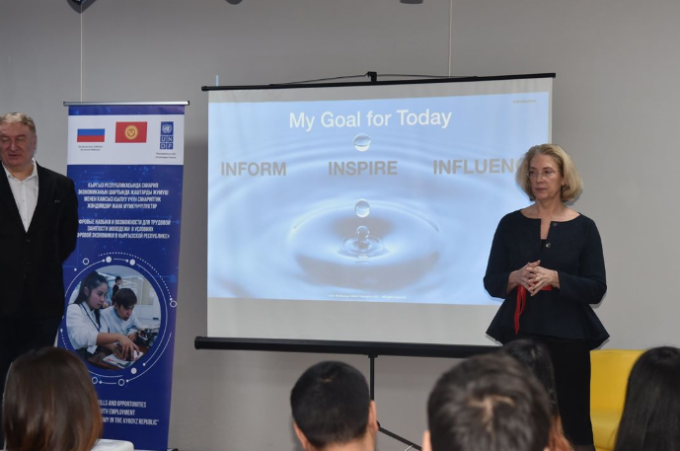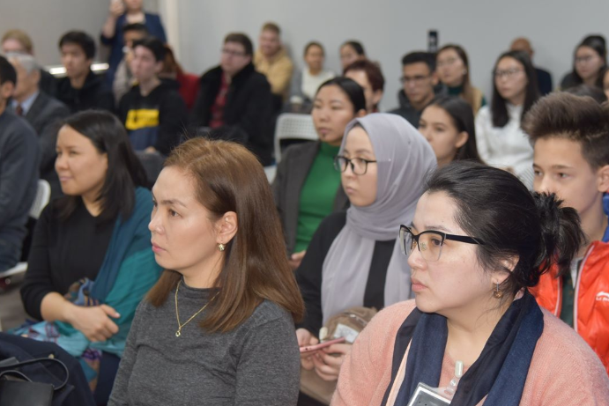
Conference on Digital Transformation in Central Asia
The University of Central Asia (UCA), the State Committee on Information Technologies and Communications and the High Technology Park (HTP) of the Kyrgyz Republic held a conference on the topic of “Digital Transformation in Central Asia” (DTCA). UNDP partially supported this conference. This first conference will probably become an annual event and a place of attraction for the best specialists in this field, with the aim of sharing experience and cooperation in the productive transformation of Central Asia into the digital age. The President of the Kyrgyz Republic Sooronbai Jeenbekov opened the conference, which earlier declared 2019 the Year of Regional Development and Digitalization. The DTCA conference is organized jointly with the Government of the Kyrgyz Republic.
This conference provided Information Technology (IT) leaders the opportunity to connect with over a hundred Chief Information Officers and IT leaders from within Central Asia and abroad, in both the government and private sectors. Besides providing an unprecedented opportunity for networking with the best minds in the business, the presence of representatives from companies such as Microsoft, Cisco, Oracle, and SAP, as well as Telecommunications, Mining, and Energy fields in Central Asia, provide a window into the depth of expected dialogue and discussion.

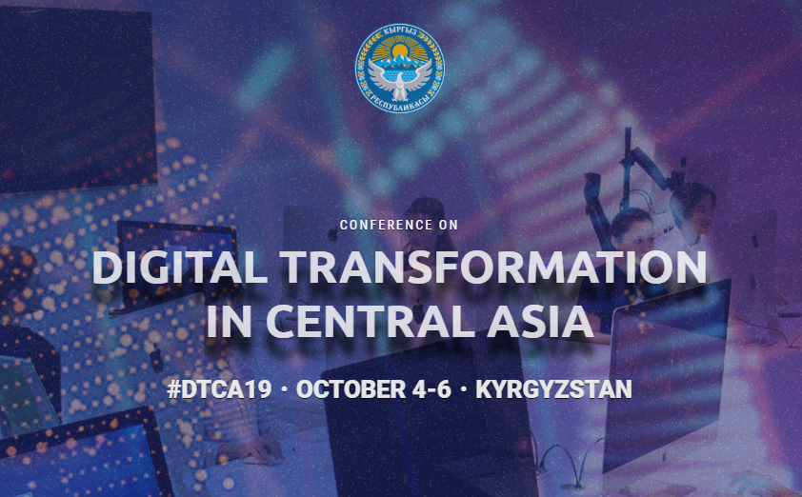

3. PROJECT RISKS

The project monitoring and evaluation indicators planned for achievement in the project document are somewhat overstated and not adequate to the available financial resources. In this regard, it is necessary to revise some indicators and make appropriate changes after consultation with the donor and members of the project management board.

4. LESSONS LEARNT

When planning similar projects in the future, it is recommended to conduct in-depth studies with closer and regular consultations with national partners from government and business both at the central and local levels. Market research should be conducted at the initial stage of the project to obtain important baseline indicators. It is important to choose the main national partner who is extremely interested in the final results of the project and has strong partnerships with other actors in the development process, especially from the private sector.

5. FUTURE PLANS

Component 1.
There is a good solution in merging activities 1,3; 1,4; 1,5; 1,6. The National Strategy on Digital Skills and Competencies and Action Plan should be developed. Besides, modernization of education standards and education programs for the formation of fundamental and innovative digital skills, introducing and implementing on a pilot basis new educational standards and curricula in pilot educational institutions in KSTU and OshTU, strengthening the institutional potential at the selected pilot educational institutions.
Reform in the education system, which currently consists of 52 universities in Kyrgyzstan, according to the concept of “Model of 4th Generation Universities”, requires a lot of investment and effort from a legal point of view, the preparation of regulatory documents, such as legislative acts, resolutions and other documents.

Modern models of 4th generation universities include the following components:
- Teaching
- Research
- Production
- Innovation

We will implement as a pilot project the 4th generation of Education in both universities.

Component 2.
In Osh city, there is a need to create space for new start-ups, co-working, accelerators, business trainings, online meetings and other conducted events like in Bishkek and abroad and with which you can organize permanent video bridges. This space should meet the new format and design requirements. In this regard, work will continue to improve digital skills and competencies in online and offline formats. The main decisions and mechanisms to be implemented:
- Develop online Learning Management System platform or improve the current portal www.digiskills.kg that launched the State Committee on Information Technologies and Communications (SCITC). This platform should be sustainable technically supported and maintained during minimum one year with selected partner;
- Develop online training courses in local and external e-commerce, internet/digital marketing, blogger, YouTube, SEO, SMM, digital resilience and many other contents in Kyrgyz and Russian languages;
- The IT Hub in Osh should be supported technically as well as human resources. Problems regarding the building / premises should be resolved. It is necessary to hire an event manager for the High Technology Park (HTP) so that there should be a responsible person in the south who will organize many events to attract young people and interested beneficiaries.
- Negotiations began on joint events with Google and Microsoft Academies to translate digital content into local languages ​​and other joint events;
- Planned activities with the Soros Foundation, USAID, IFC with joint coverage of costs for their implementation.

6. PARTNERSHIPS
Component 1:
Main partners are the Ministry of Education, SCITC, KSTU and OshTU

Component 2:
For now preliminary negotiations provided with HTP, Russian-Kyrgyz Foundation, OLOLO, Social Initiative of Internet Policy, Business Associations and other stakeholders.

7. PARTNERSHIP WITH THE RUSSIAN FEDERATION
Cooperation with Russian institutions.
For the first component both pilot KSTU and OshTU are the members of Unions of Universities in CIS countries where the leading Russian universities are working with. To develop the new educational standards and to implement the 4th generation of education it is planned to work with Russian technical universities. Plan to do study tours, TOT for university staff and improvements of education level.

Use of Russian expertise.

To conduct an intensive exchange of knowledge and master classes, it is necessary to attract experienced specialists in the field of digital technologies from Skolkovo, Kazan Technopark and other world creative spaces, to transfer know-how and to start a digital business and create new business models for scaling successful business technology solutions tested in the Russian Federation.

8. COMMUNICATION AND VISIBILITY
Hackathon and business trainings:
https://www.kg.undp.org/content/kyrgyzstan/ru/home/presscenter/pressreleases/2019/12/osh-hackathon-successfully-completed-.html
https://www.facebook.com/undpkg/posts/2526523090776918
https://twitter.com/undpkg/status/1194849365464141825?s=20

https://twitter.com/undpkg/status/1194935247181426688?s=20
https://flickr.com/photos/undpkg/albums/72157711775782957

Amazon meetups
https://www.kg.undp.org/content/kyrgyzstan/ru/home/presscenter/pressreleases/2019/12/with-the-help-of-undp--a-student-started-doing-business-in-amazo.html
https://flickr.com/photos/undpkg/albums/72157712179510731
https://twitter.com/undpkg/status/1205094419239751681?s=20

https://twitter.com/undpkg/status/1205098133274996741?s=20

Robotics:
bit.ly/2R58Yg6
https://flickr.com/photos/undpkg/albums/72157712125561687
https://twitter.com/undpkg/status/1203665492701040642?s=20

https://twitter.com/undpkg/status/1203568165692854273?s=20

IT Women: “IT expert from Kyrgyzstan destroys stereotypes about girls”
https://www.kg.undp.org/content/kyrgyzstan/ru/home/presscenter/articles/2019/12/it-expert-from-kyrgyzstan-destroys-stereotypes-about-girls.html

https://www.kg.undp.org/content/dam/kyrgyzstan/Publications/Bayan%20magazine/bayan_kyrg_IV_2019.pdf

Cyber and digital security
https://www.facebook.com/notes/undp-in-the-kyrgyz-republic/%D0%BA%D0%B8%D0%B1%D0%B5%D1%80%D0%B1%D0%B5%D0%B7%D0%BE%D0%BF%D0%B0%D1%81%D0%BD%D0%BE%D1%81%D1%82%D1%8C-%D0%B3%D0%BB%D0%B0%D0%B7%D0%B0%D0%BC%D0%B8-%D1%8D%D0%BA%D1%81%D0%BF%D0%B5%D1%80%D1%82%D0%B0/2716853388410553/
https://www.flickr.com/photos/undpkg/albums/72157713076639777
Career and practice day in KSTU
https://www.facebook.com/notes/undp-in-the-kyrgyz-republic/%D0%BF%D1%80%D0%BE%D0%BE%D0%BD-%D0%BF%D0%BE%D0%B4%D0%B4%D0%B5%D1%80%D0%B6%D0%B0%D0%BB-%D0%B4%D0%B5%D0%BD%D1%8C-%D0%BA%D0%B0%D1%80%D1%8C%D0%B5%D1%80%D1%8B-%D0%B8-%D0%BF%D1%80%D0%B0%D0%BA%D1%82%D0%B8%D0%BA%D0%B8-%D0%B2-%D0%BA%D0%B3%D1%82%D1%83-%D0%B8%D0%BC-%D1%80%D0%B0%D0%B7%D0%B7%D0%B0%D0%BA%D0%BE%D0%B2%D0%B0/2720198071409418/
https://www.flickr.com/photos/undpkg/albums/72157713099997001

- FINANCIAL MANAGEMENT
Output | Budgeted for the reported year | Delivered for the reported year | Delivery rate for the reported year (%) | Budgeted for the entire project | Delivered since the project start
Activity 1. Improved digital skills development in the system of formal education | 145 800,00 | 46 927,98 | 32,19% | 410 000,00 | 11,45%
Activity 2. Established ITHubOsh in Osh City for young entrepreneurs and application of new learning models in non-formal educational settings | 165 240,00 | 33 703,57 | 20,40% | 393 500,00 | 8,57%
Activity 3 Project Management (salaries) | 14 594,00 | 13 301,92 | 91,15% | 106 650,00 | 12,47%
Activity 4 Administrative costs | 1 728,00 | 2 546,94 |  | 15 775,93
GMS | 24 249,00 | 4 693,79 | 19,36% | 74 074,07 | 6,34%
Total | 351 611,00 | 101 174,20 | 28,77% | 1 000 000,00 | 10,12%

In addition to the budget summary table please attach a Combined Delivery Report as an annex.

*With commitments
*Comments: 2019 figures are not final and subject to change, as FY2019 is not yet closed officially in Atlas.

Submitted by __Kanagat Alyshbaev, Project coordinator Digital skills and opportunities for youth employment towards digital economy in the Kyrgyz Republic

Date__30.01.20
Attachment 1. Order of the Ministry of Education
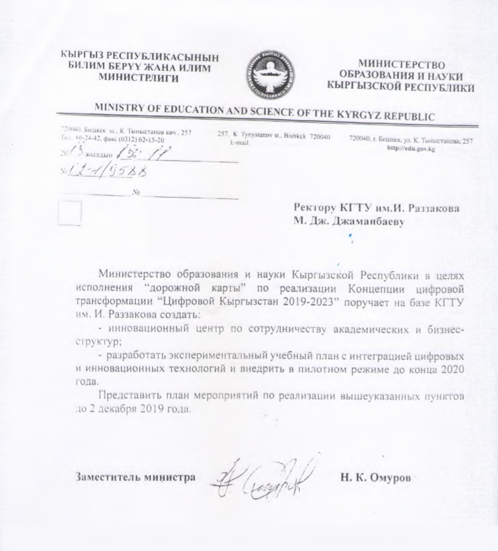

Attachment 2: KSTU’s Events plan on implementation of Digital Kyrgyzstan Conception (page 1)
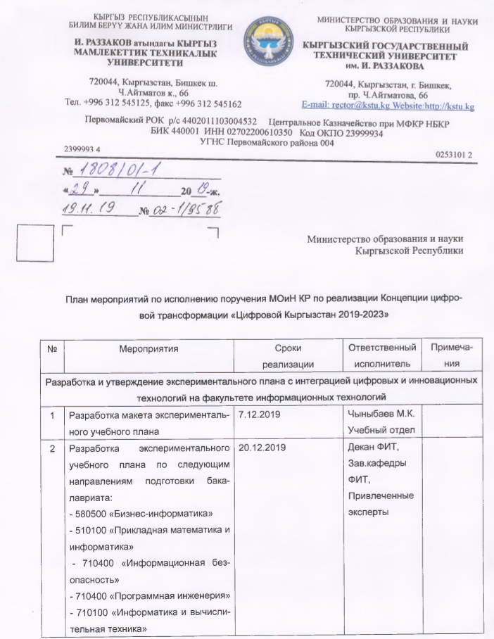

Page 2
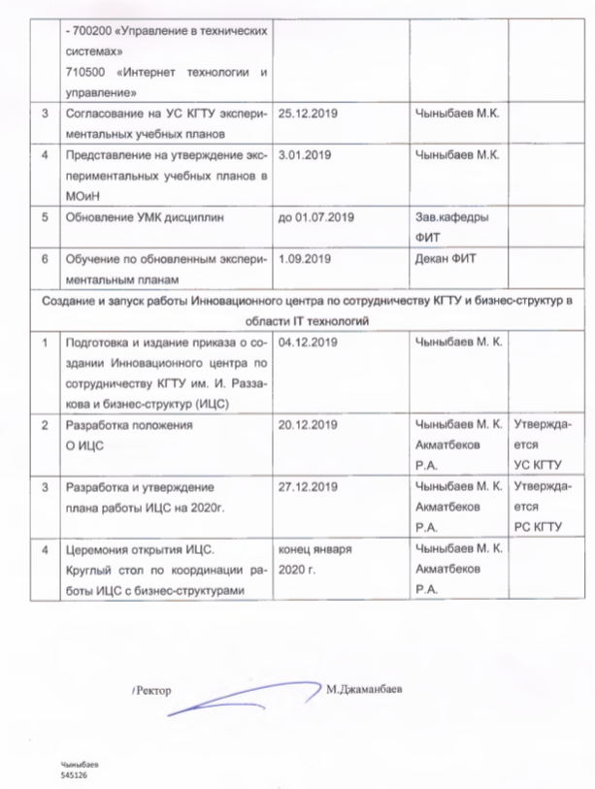

Attachment 3. Oracle Partnership Agreement draft’s 1st page

